HTML Guide Line Form

* ***Primary Colors of the Web site*** **:** FF65A1 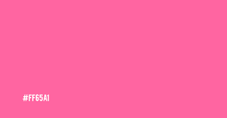

FFF8B4 

FF0064 

00758F 

8FA6AB 

* ***Background color* :**  FFF8B4 
* ***Font Style for Titles* :** font-family: **'Roboto Mono'**, monospace;

font-family: '**Inconsolata'**, monospace;

font-family: **'Markazi Text'**, serif;

* ***Font Style for Sub Titles***
* h1 title font = **“Roboto+Mono”** Color = 
* h2title font = **“Inconsolata”** Color = 
* ***Paragraphs***
* font = “**Markazi+Text”** Color = 
* ***Anchors***
* Normal Behavior =
* After hover Effect=
* ***Images***
* Use Images that suit for the web site
* Don’t use black and white images
* **Maps**
* Use Static maps only.